Activity Sheet Answers
Chapter 5, Lesson 7
Can Liquids Dissolve in Water?

DEMONSTRATION

- Your teacher placed some food coloring in water. Did the food coloring dissolve in the water?
Yes, the food coloring dissolved in water.

How do you know when a solute, like food coloring, has dissolved in a solvent, like water?
You can tell that a solute has dissolved in a solvent when the solute is completely incorporated into the solvent and won’t settle out.

ACTIVITY
2. Based on your observations of the way isopropyl alcohol, mineral oil, and corn syrup dissolve in water, would you say that solubility is a characteristic property of a liquid? Why?
Yes, solubility is a characteristic property of a liquid. This was demonstrated in the activity by the fact that each of the three liquids combined with water in different ways.

EXPLAIN IT WITH ATOMS & MOLECULES
Look at the structure of the molecules in isopropyl alcohol, corn syrup, and mineral oil. Explain why either dissolves or does not dissolve in water.
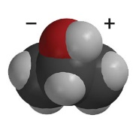  Isopropyl Alcohol | Isopropyl alcohol does dissolve in water because, like water, it is a polar molecule, with an area of slight positive and negative charge.
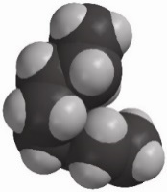  Mineral Oil | Mineral Oil does not dissolve in water because it is a non-polar molecule. It does not have any areas of slight positive or negative charge.
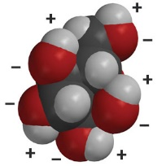  Glucose in corn syrup | Glucose dissolves in water because it is a polar molecule. It has areas of slight positive and negative charge.

3. In some salad dressings a layer of oil, like canola or olive oil, floats on top of a layer of vinegar, which is mostly water. If you shake the bottle of salad dressing, the liquids will temporarily combine. The oil and vinegar do not dissolve in one another because eventually the two liquids will separate out again. Knowing what you do about molecules and dissolving, why doesn’t the oil in these salad dressings dissolve in vinegar?
Oil and vinegar do not mix in salad dressing because oil is composed of non-polar molecules, while vinegar is composed of polar molecules.

4. Some people with diabetes may accidentally let their sugar level get too low. There are glucose tablets to help them with this problem. When a person eats one, do you think it will act quickly to increase his/her blood sugar level? Why or why not?
Yes, a glucose tablet should quickly increase a diabetic’s glucose level because glucose is a polar molecule and should quickly and easily dissolve in the person’s bloodstream.

TAKE IT FURTHER
5. What do you observe when the drop of alcohol and drop of water combine?
Answers will vary, but students should note how the alcohol and water appear to “shake” as they combine.

6. Your teacher combined 50 mL of isopropyl alcohol and 50 mL of water. What is surprising about the result?
When 50 mL of water and 50 mL of isopropyl alcohol are combined, you get about 97 mL of total solution! That means the sum seems to be less than the two parts.

